**“Effect of Bismuth Doping On Gel Grown Lead Iodide Crystals”**

A PROJECT REPOSRT SUBMITTED TO

PRATAP COLLEGE AMALNER (Autonomous)

(An affiliated to KBC NORTH MAHARASHTRA UNIVERSITY JALGAON)

FOR THE DEGREE OF

MASTER OF SCIENCE

IN

PHYSICS

UNDER THE FACULTY OF SCIENCE

BY

MISS. KASAR SAMRUDDHI ANIL

Department of Physics, Pratap College Amalner (Autonomous)

UNDER THE GUIDANCE OF

Dr . Amit B. Patil

DEPARTMENT OF PHYSICS

PRATAP COLLEGE AMALNER, 425401

APRIL 2024

CARTIFICATE

This is certifying that the work incorporated in the project report entitled **“Effect of Bismuth doping on gel grown lead iodide crystals”** submitted to Pratap College Amalner, is benefited work of **Miss. Samruddhi Anil Kasar** of M.Sc. (Physics) during the **academic Year 2023-24** who carried out the project work under my supervision.

**Dr . A. B. PATIL Dr . J. B. PATWARDAN**

Guide Head

Department of Physics Department of Physics

Pratap College Amalner, Pratap College Amalner,

425401 425401

**Internal Examiner External Examiner**

Date: / 05/ 2023

ACKNOWLEDGEMNET

I wish to thank the Principal **Dr . A. B. JAIN** of my college for permitting me to use all the facilities available in the institution for my project work. I would also like thank the Head of the Physics Department Prof. **Dr . J. B. PATWARDHAN.** The teaching faculty and all the non-teaching staff of my college for their support in completing the work successfully.

I am grateful to my Guide Prof**. Dr . A. B. PATIL** for his encouragement, Guidance and supervision of my project work during the year. I must acknowledge the financial support given to this project by my parent without which it would have been difficult to complete the work in time.

My classmates have been of great help to me the project work. My ideas were shaped and refined progressively through my discussions with them from time to time. I cannot miss to thank them all. There were some persons like Prof. **S. K. Nerkar** who were directly involved in my practical work. I appreciate their contribution and thank them too.

**Place :-AMALNER Signature of Research Student**

**Date :- /04/2024** SAMRUDDHI ANIL KASAR

ABSTRACT

The optical and structural investigation of bismuth-doped and undoped lead iodide have been described Bismuth-doped and undoped of lead iodide crystals have been grown by gel method using single diffusion method. The single crystals of pure and bismuth doped lead iodide have been synthesized by gel method. The growth parameters were varied to optimize the suitable growth condition .Optimum conditions to grow these crystals have been obtained Such as pH, effect of density and aging of gel, concentration, temperature. The optical and structural properties of the crystals were investigated using X-ray diffraction, UV-VIS spectroscopy.

XRD confirm the structure of bismuth-doped lead iodide and pure lead iodide as same hexagonal structure, also the lattice parameters are closely matching with JCPDS data of lead iodide. Band gap energy of lead iodide crystal was calculated from the UV-VIS spectrometry. I have observe the band gap energy decreases dopant concentrations. The absorption edge shifts towards the higher-wavelength side and becomes broader as the doping concentrations are increased.

INDEX

*INTRODUCTION

CHAPTER.1 INTRODUCTION OF CRYSTAL GROWTH

* 1. Crystal growth technique

CHAPTER.2

2.1 Different Technique of Crystal Growth

2.2 Gel Growth

2.3 Gel Characteristic

2.4 Advantages of Gel Technique

2.5 Disadvantage of Gel Technique

2.6 Gel Preparation in Properties

2.7 Method of Gel Technique

2.8.1 Chemical Reaction M Method

2.8.2 Chemical Reduction Method

2.8.3 Solubility Reduction Method

2.8.4 Complex Dilution

CHAPTER 3. SYSNTHESIS OF CALCIUM IODATE CRYSTALS

3.1 Preparation of Sodium Metasilicate Solution

3.2 Growth of lead iodide By Gel Method

3.3 Preparation of Gel

3.4 Supernatant

3.5 Temperature

CHAPTER 4. RESULT AND DISCUSSION

4.1 XRD Studies

4.2 UV-VIS

4.3 Conclusion

INTRODUCTION

# **Lead Iodide**

Firstly, the lead iodide formula or the lead iodide II is a salt. Moreover, at the room temperature, it is a bright yellow colour odourless crystalline solid that turns into orange and red when we heat it. It was previously called as the plumbous iodide.

This compound currently has some specialized applications, like the manufacturing of the solar cells and the X-ray and the gamma-ray detectors. However, its preparation is an entertaining and popular demonstration in the vast field of chemistry education, for teaching these topics such as the precipitation reactions and the stoichiometry.

It decomposes by the light at a moderately high level of the temperatures and we are using this effect in a patented photographic process as well. The lead iodide was previously employed as a yellow pigment in a few types of paints, with the name iodide yellow. However, that use is now not in continuation due to its toxic nature and at the same time due to its poor stability.

**BISMUTH**

**Bismuth** is a [chemical element](https://en.wikipedia.org/wiki/Chemical_element); it has [symbol](https://en.wikipedia.org/wiki/Symbol_(chemistry)) **Bi** and [atomic number](https://en.wikipedia.org/wiki/Atomic_number) 83. It is a [post-transition metal](https://en.wikipedia.org/wiki/Post-transition_metal) and one of the [pnictogens](https://en.wikipedia.org/wiki/Pnictogen), with chemical properties resembling its lighter [group 15](https://en.wikipedia.org/wiki/Group_15) siblings [arsenic](https://en.wikipedia.org/wiki/Arsenic) and [antimony](https://en.wikipedia.org/wiki/Antimony). Elemental bismuth occurs naturally, and its [sulfide](https://en.wikipedia.org/wiki/Sulfide" \o "Sulfide) and [oxide](https://en.wikipedia.org/wiki/Oxide) forms are important commercial [ores](https://en.wikipedia.org/wiki/Ore). The [free element](https://en.wikipedia.org/wiki/Free_element) is 86% as dense as lead. It is a brittle metal with a silvery-white colour when freshly produced. [Surface oxidation](https://en.wikipedia.org/wiki/Passivation_(chemistry)) generally gives samples of the metal a somewhat rosy cast. Further oxidation under heat can give bismuth a vividly [iridescent](https://en.wikipedia.org/wiki/Iridescence) appearance due to [thin-film interference](https://en.wikipedia.org/wiki/Thin-film_interference). Bismuth is both the most [diamagnetic](https://en.wikipedia.org/wiki/Diamagnetism) element and one of the least [thermally conductive](https://en.wikipedia.org/wiki/Thermal_conductivity) metals known.

Lead iodide, PbI2, is a direct band gap p-type semiconductor with a layered structure. The atomic arrangement is in the form of layers of Lead and Iodine atoms oriented perpendicularly to the caxis. They consists of molecular sheets, each consisting of a layer of cation sandwiched between two layers of hexagonal close packed anion. The forces within the sandwiched are purely ionic in nature, giving a strong binding between an anion and cation layer, whereas the anion layer in adjacent sandwiches are held together by weak van der Wall’s forces of attraction. The layers can be stacked in a variety of ways to form different types of polyptism.

This material has been the subject of many investigations due to specific technological features, for instance, its large applicability, at room temperature, as photocell, and x- and γ-ray detector [1-6]. Lead Iodide is more attractive than other similar materials, such as HgI2, because of its lower vapour pressure and lack of a destructive phase transition, which shows up at temperature around 1300C for Hg2 [1,2,5,7-9]. The electronic structure and optical properties were studied both experimentally [10-14] and theoretically [15-17].

Although studies of bulk crystals are essential for understanding some of the fundamental properties of the material, the preparation and study of high quality thin films are desirable for device applications. With an aim to investigate the effect of doping on optical properties of Lead Iodide, work on preparation and characterization of pure and synthesized doped and undoped Lead Iodide thin films in polycrystalline form has been undertaken. In the course of present investigation, we have observed that: (i) the lattice parameters ‘a’ and ‘c’ and hence the unit cell volume are sensitively affected by the dopant concentration. (ii) band gap of the undoped Lead Iodide films matches with the reported value (iii) band gap of doped Lead Iodide films were decreases significantlly. The purpose of this communication is to present effect of doping on the band gap of Lead Iodide films.

# INTRODUCTION OF CRYSTAL GROWTH

**1.1 CRYSTAL GROWTH TECHNIQUE:**

Crystals are the unacknowledged pillars of modern technology. Without crystals, there would be no electronic industry, no photonic industry, no fiber optic communications, which depend on materials/crystals such as semiconductors, superconductors, polarizer, transducers, radiation detectors, ultrasonic amplifiers, ferrites, magnetic garnets, solid state lasers, non-linear optics, Piezo-electric, electro-optic acousto-optic, photosensitive, refractory of different grades, crystalline films for microelectronics and computer industries. Crystal growth is an interdisciplinary subject covering physics, chemistry, material science, chemical engineering, metallurgy, crystallography, mineralogy, etc. In the past few decades, there has been a growing interest on crystal growth processes, particularly in view of the increasing demand on materials for technological applications (Brice 1986, Nalwa and Miyata 1997). Atomic arrays that the are periodic in three dimensions, with repeated distances are called single crystals. It is clearly more difficult to prepare single crystal than poly-crystalline material of solids, are obscured or complicated by the effect of grain boundaries. The chief advantages are the anisotropy, uniformity of composition and the absence of boundaries between individual grains, which are inevitably present in polycrystalline materials. The strong influence of single crystals in the present day technology is evident from the recent advancements in the above mentioned fields. Hence, in order to achieve high performance from the device, good quality single crystals are needed. Growth of single crystals and their characterization towards device fabrication have assumed great impetus due to their importance for both academic as well as applied research.

Nonlinear optical crystals are very important for laser frequency conversion (Kurtz 1968). Potassium dihydrogen phosphate (KDP) is suitable for higher harmonic generation of huge laser systems for fusion experiments because it can

be grown to larger sizes and also KDP has a high laser damage threshold. Potassium titanyl phosphate (KDP) is a useful nonlinear optical crystal to get efficient green light by the frequency doubling of Nd:YAG laser. It has high optical nonlinearity, large temperature and angular allowance and it is non hygroscopic and mechanically hard. The method of growing crystals varies widely, it is mainly dictated by the characteristic of the material and its size (Buckley 1951 and Mullin 1976). In recent years there has been considerable progress in the development of coherent UV sources based on non-linear optical processes. The demand for nonlinear optical crystals with superior properties is increasing due to quantum jump in the design of nonlinear optical devices with higher performance. With the progress in crystal growth technology, materials having attractive nonlinear properties are being discovered at a rapid pace (Bamert et al 1987, Chemla and Zyss 1987, Gunter et al 1987 and Warren 1990). To enable a material to be potentially useful for NLO applications, the materials should be available in bulk single crystal form (Bailey 1991). And so, crystal growth of new nonlinear optical materials and investigation into their properties have become most indispensable and efficacious disciplines in the field of materials science and engineering. The rapid development of optical communication system has led to a demand for Nonlinear Optical (NLO) materials of high performance for use as components in optical devices. NLO material are used in frequency conversion, which is a popular technique for extending the useful wavelength range of considerable potential and high performance. There are three major stages involved in this research. The first is the production of pure materials and improved equipment associated with the preparation of these materials. The second is the production of single crystals first in the laboratory and then extending it to commercial production. The third is the characterization of utilization of these crystals in devices. In this section, various methods of crystal growth with emphasis on low temperature solution growth technique are described. The solvent to be chosen to grow good quality crystals from solution, the effect of supersaturation and pH value of the solution is also discussed.

# DIFFERENT TECHNIQUE OF CRYSTAL GROWTH

Growth of crystal ranges from a small inexpensive technique to a complex sophisticated expensive process and crystallization time ranges from minutes, hours, days and to months. Single crystals may be produced by the transport of crystal constituents in the solid, liquid or vapor phase. On the basis of this, crystal growth may be classified into three categories as follows,

Solid Growth - Solid-to-Solid phase transformation

Liquid Growth - Liquid so Solid phase transformation

Vapour Growth - Vapour to Solid phase transformation

Based on the phase transformation piece of material into single crystal by causing the grain boundaries to be trough and pushed out of the crystal takes place in the solid-growth of crystals (Mullin 1972). The above methods have been discussed in detail by several authors (Brice 1986, Pamplin 1980, Chernov 1984). The different techniques of each category are found in reviews and books by Faktor and Garret (1974) on vapor growth, Brice (1973) on melt, Henisch (1988) on gel growth, Buckley (1951) on solution growth and Elwell and Scheel (1975) on high temperature solution growth.

An efficient process is the one, which produces crystals adequate for their use at minimum cost. Better choice of the growth method is essential because it suggests the possible impurity and other defect concentrations. Choosing the best method to grow a given material depends on material characteristics.

In the above mentioned categories liquid growth includes both melt and solution growth. A survey of the methods of growth suggests that almost 80% of the single crystals are grown from the melt compared with roughly 5% from vapour, 5% from low temperature solution, 5% from high temperature solution, and 3% from the solid and only 2% by hydrothermal methods.

In contrast to the historical work, it seems that the essential task for the crystal growers at present is to gain basic knowledge about the correlation of crystal properties and the growth conditions defined to be special parameters. This basic understanding of the deposition of atoms onto a suitable substrate surface - crystal growth - the generation of faults in the atomic structure during growth and subsequent cooling to room temperature - crystal defect structure, are the input for the design of crystal growth systems and control of growth parameters. Though the fundamentals are relatively simple, the complexities of the interactions involved and the individualities of different materials, system and growth process have ensured that experimentally verifiable predictions from scientific principles have met with limited success - good crystal growth remains as art. As a result, crystal growth has long had the image of alchemy. This is clearly expressed by the title of one of the first text books on crystal growth 'The Art (!) and Science of Growing crystal' (Gilman 1963). The recent advances transport variables and the use of better controlled energy sources to promote specific reactions, coupled with increased development and application of in-situ diagnostic techniques to monitor and perhaps the ultimate control lead to simplified growth system and the crystal growth process has transferred and the field from an art to to science, technique and to technology.

**2.3 GEL GROWTH**

The growth of variety of crystals having immense importance for their practical consideration and theoretical interest has been achieved by gel technique (Helisch 1988). The importance of the gel growth is attributed to it simplicity in technique, effectiveness in cannot easily be grown by other methods. Though the origin of the method dates back to 1899 - the famous work of Liesegang who discovered the periodic crystallization in gels, interest gel technique received attention only after the work of Henisch and his co-workers (Henisch 1970; Henisch 1988; Henisch and Garcia-Ruiz 1986). Crystal growth in gels is a promising technique for growing single crystals of substances which are slightly soluble in water and which cannot be grown conveniently from melt of vapour. The gel method has also been applied calculi to study the crystal formation in urinary calculi and rheumatic diseases.

**2.4 GEL CHARACTERISTICS**

A gel is a two component system, highly viscous, semi -solid in nature and having fine pores through which diffusion takes place. Gel can be classified into two categories.

(1) Physical gel: Gel which is obtained by physical process such as cooling or warming. Examples are gelatine, agar-agar and cellulose.

(2) Chemical gel: Gels formed by chemical reaction such as hydrolysis or polymerization. Example are silica ( water glass ) and polyacrylamide.

The gel can be regarded as a loosely interlinked polymer. When the dispersion medium is water, the material should be called 'hydrogel' to distinguish it from the brittle solids, which are often obtained by subsequent drying. The density and other precise conditions such as pH of gel, ageing etc. Gels can be prepared from organic as well as inorganic materials. Among these gels, silica gel is a versatile medium for growing crystals.

**2.5 ADVANTAGES OF GEL METHOD:**

1. Crystal growth takes place at ambient temperatures and hence crystal defects are reduced.
2. The crystal can be observed practically in all stages of their growth.
3. This method enables the control of the rate of reaction required for crystallization for a particular material.
4. All crystals are held in the position of their formation and this limits the effects due to impact on the sides of the container.
5. The gel medium prevents convection currents and turbulence.
6. The number of nucleation sites and the size and morphology of the crystals can be controlled by changing the growth conditions.
7. Since all nuclei are spatially separated, the interaction between them is considerably diminished.
8. The growth procedure is simple and economical.

A few disadvantages of this method are the limitation of the crystal size and the time delay in growing the samples.

**2.6 DISADVANTAGE OF GEL METHOD:**

1. Gel trapping during the growth occurs in some crystals when a silica gel is used.
2. Growth period is usually very long.
3. Crystal size is generally small.

**2.7 GELS PREPARATION AND PROPERTIES:**

A highly viscous two-component system of a semisolid nature, rich in liquid and having fine pores in it is referred to as 'Gel'. It is not viscous as liquid and not hard as solid. It is having the state between liquid and solid. Since it is not having viscosity it is called as semi- solid and not semi-liquid. Silica gel called Silica hydrogel prepared from sodium metasilicat solution. Pores are separated by solid film 2 X 10-5 cm thickness, where the dimensions of pores depend on the concentration of gel materials. One gel can be distinguished from another by the nature of porse distribution from another.

Various substances which are termed as 'Gel' are as follows

1. Silica gel
2. Agar gel
3. Gelatine gel
4. Clay gel
5. Soap fluid
6. Poly acrylamide
7. Polyvinyl Amide
8. Oleates.
9. Stearates
10. Aluminates
11. Dense solution of metal hydroxide etc.

Gelling process can be brought about in a number of ways such as by cooling, by chemical reaction, by warming, by addition of participating agents.

It may be mentioned that silica gel has been most commonly used because of its far better than all other gels. Silica gel is also called as silica hydrogel or water glass or silicate glass. This gel is usually prepared from aqueous solution of sodium metasilicate.

**1.5 GELLING MECHANISM AND STRUCTURE OF SILICA HYDROGEL:**

The gelling mechanism can be explained as follows be considered acid is produced, in accordance with the dynamic equilibrium.

**Na2SiO3 + 3H2O = H4SiO4 + 2NaOH**

OH OH OH OH

| | | |

OH---Si--- OH + OH---Si---OH→OH---Si---O---Si---OH + H2O-

| | | |

OH OH OH OH

**This can happen again and again until a three-dimensional network of Si-O links are established in silica gel.**

When the polymerization process continues, water accumulates on the top of the gel surface, a phenomenon is known as "Syneresis". The time required for gelation is very sensitive to pH and it is known that, two types of ions are produced (H3SiO4- and H2SiO4). High pH-values favour the formation of H2Sio4 -ions are moderately favoured by low pH values and are responsible for the formation for a long chain of polymerization products. Gradually cross linkages are formed between these chains and they contribute to the sharp increase in viscosity which gives the indication of gel setting.

**2.8 DIFFERENT METHOD OF GEL TECHNIQUE:-**

The crystal growth by gel techniques way be classified into the following four methods.

1. Chemical reaction method.
2. Chemical reduction method.
3. Solubility reduction method.
4. Complex dilution.

**2.8.1 CHEMICAL REACTION METHOD :**

In this method aqueous solutions of two reactants are allowed to diffuse through a gel so that a slow and controlled segregation of ions and molecules occurs resulting in the precipitation of an insoluble crystalline product. The chemical reaction is

**AX + BY → AY + BX.**

Here AX and BY are two water soluble compounds which on reaction give rise to AY, the insoluble crystal and BX, the waste product which is soluble in water.

Any one of the following methods can be adopted to achieve this reaction.

1. Incorporation of one component of the reaction AX in the gel is prior to gel setting [26]. The second component BY is poured on to the gel after proper setting [Figure 2.1a]
2. Using a two-gel technique, of which one is neutral gel [27]. This technique involves preparation of a gel containing one of the reactant AX in the lower part of the test tube [Figure 2.1 b]. Then a second gel column, free from any of the reacting ions, termed as neutral gel, is formed above the first gel. The other reacting component is poured over the neutral gel to facilitate diffusion.
3. Forming a gel over a packet containing the component AX and pouring a solution of BY over the set gel. [Figure 1]

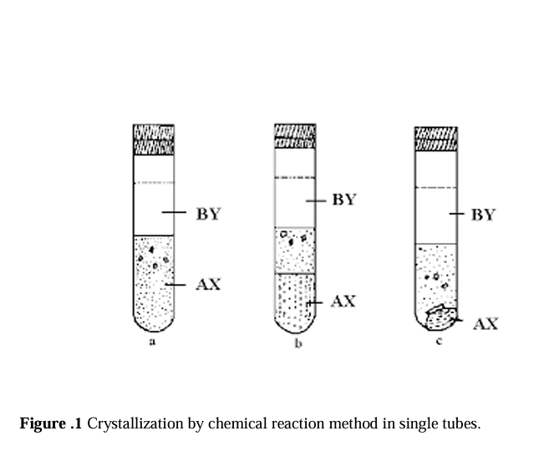

**2.8.2 CHEMICAL REDUCTION METHOD**

Metal crystals are grown by this method. The metallic complex is taken along with the sodium metasilicate solution and is reduced by means of diffusion by a proper reducing agent into the gel. Slow reduction results in the formation of metallic crystals. For the growth of copper crystals, copper sulphate is incorporated into the gel.

The Reducing agent is hydroxylamine hydrochloride or hypo phosphoric acid poured over the set gel. Crystals of copper, nickel, cobalt, gold, lead etc. [40, 41] have been grown by this technique.

**2.8.3 SOLUBILITY REDUCITON METHOD**

This method is employed for the growth of crystals of water soluble substances. The substances to be grown are dissolved in water and incorporated with the gel forming solution. After the gelation, a solution which reduces the solubility of the material is added over the set gel to initiate crystallization. Potassium dihydrogen phosphate crystals have been grown by this method by adding ethyl alcohol over the gel containing a saturated solution of KDP [42].

**2.8.4 COMPLEX DILUTION METHOD**

A chemical complex of the material to be grown is prepared with a complexing agent and then allowed to diffuse into a gel, free of active reagents. De-complexion is achieved by steadily increasing the dilution and this leads to the higher supersaturation necessary for crystal growth. Armington and O’Conner [43] used this technique for growing cuprous chloride crystals. Cuprous chloride is complexed with hydrochloric acid and then allowed to diffuse into a gel with HCl and free of other active reagents. De-complexing sets in with increasing dilution leading to high super saturation of cuprous chloride.

# SYNTHES IS OF LEAD IODIDE CRTSTALS.

**3.1 GROWTH OF LEAD IODIDE BY GEL METHOD:**

**1) INTRODUCTION:**

Crystal growth is heterogeneous chemical process of bismuth lead iodide in which conversion from one phase to another phase of a compound is involved.

This method can be used to grow crystal of wide variety of compounds. Materials required in modern devices should not only be of high purity but should also have high degree of perfection in crystalline structure with minimum defects. This aspect has been satisfied by gel technique, which is simple with good control over nucleation, quality of crystal produces and is less expensive.

**3.2 PREPARATION OF GEL:**

2N (5 cc) acetic acid solution and 0.4M (5 cc) lead nitrated was taken in a beaker, to which sodium metasilicate solution was added drop by drop with continuous stirring by using a magnetic stirrer, still pH is 4.2 . To this 5 cc mixing of , 0.4M (5cc) bismuth nitrate was added. Then stir this solution. Then pour this solution in a test tube. The mouth of the tube was covered by cotton plug. The mixture appeared to be quite transparent become slightly milky. The gel setting time was about 15 days. The period of gel setting also depends upon pH. Higher the value of pH, shorter is time of gel setting.

**3.4 SUPERNATANT:**

Potassium iodide was used as the feed solution. Its concentration is 0.4M were added over the set gels.

The parameter which controlled the nucleation and growth of single crystals are found to be:

**pH of gel :**

Gels of different pH value ranging from 4.2 to 4.4 are tried. Higher pH values gave dense gels which in turn yielded poorer crystals and deduced the number of the nucleation centre.

As pH values increases above 4.4 pH, gel is set immediately and when we pour this solution in test tube; there occurs large no of bubbles. It was observed that long aging period; cracking of the gel result into channels which quickly drain the supernatant; leading to uncontrolled number nuclei and the subsequent formation of too many microcrystals.

**3.5 TEMPERATURE :**

Temperature has pronounced influence on reaction diffusion rates. As a result, nucleation density and growth rate; which gave better quality of crystals.

**EFFECT OF GEL AGING :**

To obtain the better quality of crystals and to reduce the diffusion rate, gel aging is essential. The gel ageing reduces the nucleation density and growth rate; which gave better quality of crystals.

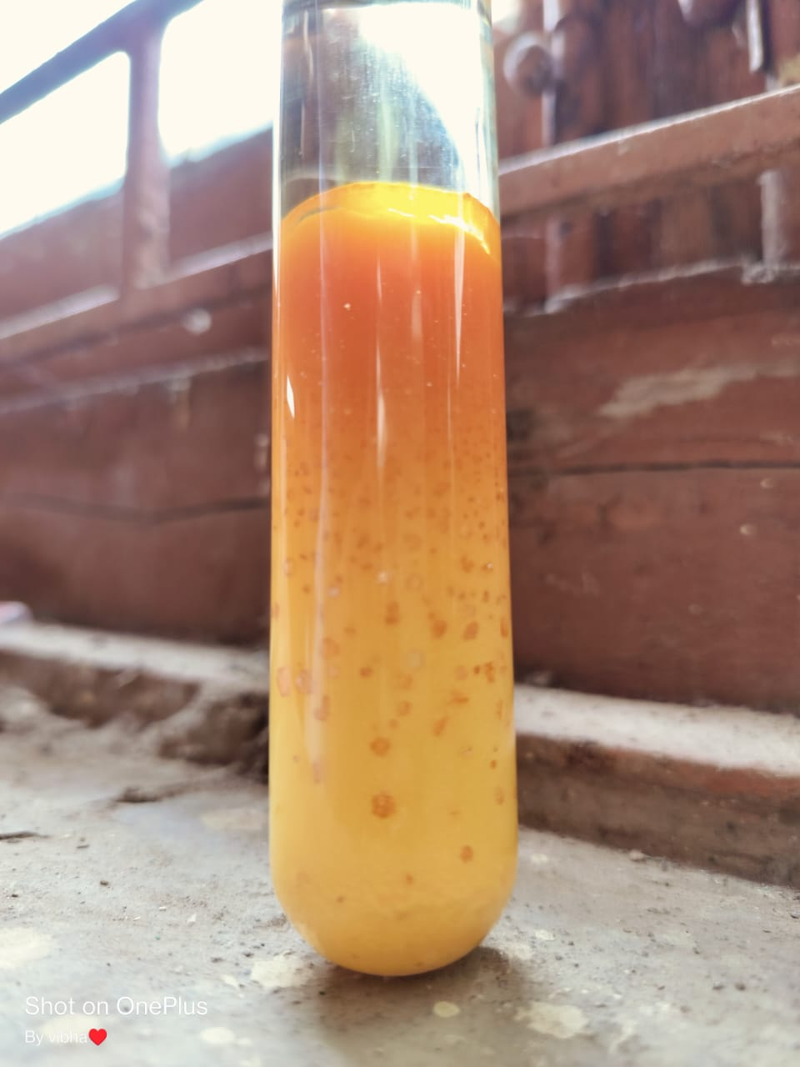

**Figure 2: Growth of Bismuth Doped Lead Iodide.**

# RESULTS AND DISCUSSION

* **XRD STUDIES**

X- ray diffraction (XRD) is a powerful nondestructive technique for characterizing crystalline materials. X-ray diffraction peaks are produced by constructive interference of a monochromatic beam of x-ray scattered at specific angles from each set of lattice planes. X-ray diffraction analysis is a powerful method by which x ray of a known wavelength are passed through a sample to be identified in order to identify the crystal structure. The wave nature of the x-ray means that they are diffracted by the lattice of the crystal to give a unique pattern of peaks of ‘reflections’ at differing angles and of different intensity, just as light can be diffracted by a grating of suitably spaced lines. The diffracted beam from atoms in successive planes cancel unless they are in phase, and the condition for this is given by the Bragg relationship:

n⅄ = 2dsin𝜃 (1)

n is the order of diffraction, ⅄ is the wavelength of the X-rays, d is the distance between different plane of atoms in the crystal lattice and 𝜃 is the angle of diffraction.

JCPDS (Joint Committee on Powder Diffraction Standards) a standard database for X-ray diffraction patterns enables quick phase identification for a large variety of crystalline samples. XRD requires minimal or no sample preparation and it works at ambient conditions for all analysis.

The crystallite size (D) can be calculated by the Scherer’s formula:

D = 𝑘𝜆/ βcos𝜃

Where, D is the crystallite size, K is proportionality constant, λ is the wavelength of X-ray, β is the full width at half maximum in radians, and 𝜃 is the angles in degrees at which the intensity peak appears.

**Applications of XRD :**

* + Identification/quantification of crystalline phase.
  + Measurement of average crystallite size.
  + Identification of unknown crystalline materials.
  + Characterization of cation-anion coordination.
  + Determination of unit cell, bond-lengths, bond –angles and site-ordering

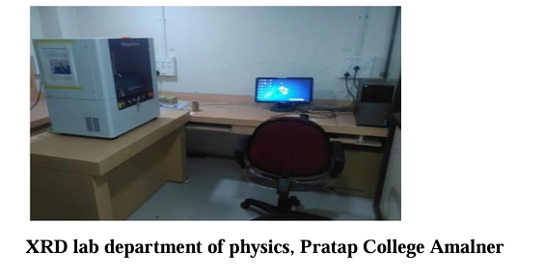

* **X-ray diffractometry of doped and undoped Lead iodide :**

Gel grown bismuth doped and undoped lead iodide crystals were powdered. X- Ray diffractograms (XRD) was collected at room temperature on a Rigaku, Miniflex model. All diffraction patterns were obtained using CuKα radiation (⅄= 1.54051Å), at 40KV and 15mA over the 2θ range of 100-800. The observed peaks of the grown crystals were matching well with the standard data file of bismuth doped lead iodide (JCPDS: 791750) and undoped lead iodide (JCPDS:731754). It indicates hexagonal structure with inter-planer distance (d) as 2.13Å. The average grain size of bismuth doped and undoped lead iodide determined by using Scherrer Formula was found to be 26.86 nm and 27.24nm. The XRD indexed peaks of bismuth doped lead iodide as shown in fig.3 and undoped lead iodide as shown in fig.2. Where bismuth doped sample shows slightly decreases intensity and grain size than the undoped sample

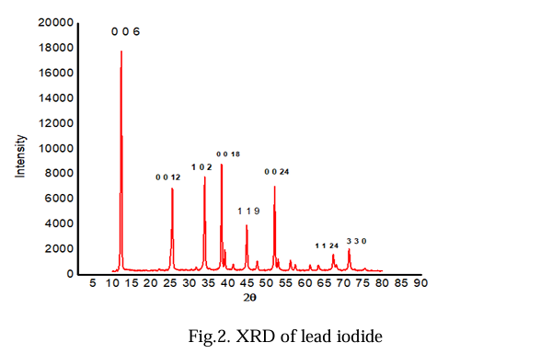

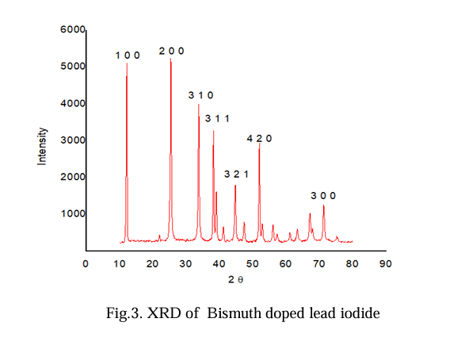

**Figure : Comparison Between XRD of Doped & Undoped Lead Iodide:**

* **UV-VIS SPECTROSCOPY STUDIES**

Ultraviolet-Visible spectrophotometer (UV-Vis or UV/Vis) refers to absorption spectroscopy or reflectance spectroscopy in the ultraviolet-visible spectral region. This means it uses light in the visible and adjacent (near- UV and near-infrared (NIR)) ranges. The absorption or reflectance in the visible range directly affects the perceived color of the chemicals involved. In this region of the electromagnetic. Spectrum, molecules undergo electronic transition. This technique is complementary to fluorescence spectroscopy. In that fluorescence deals with transition from the ground state to the excited state. UV- Visible spectrophotometer technique is used to measure band gap of the materials. The UV- Visible spectrophotometer used for the measurement of the band gap of the synthesized materials.

* **Application of UV-VIS:**
  + It used for determination of molecular weight of molecule
  + It is used in determination of impurities present in the sample
  + It is used in the characterization of aromatic compound and in detection of conjugation.
  + It is applied to detect the presence or absence of chromophore
  + It is identification of unknown compound

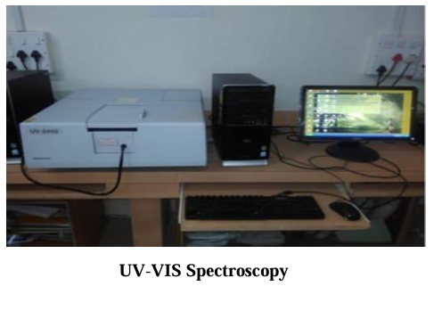

* **UV-VIS spectroscopy of doped and undoped lead iodide :**

To understand Optical properties of lead iodide. The UV-VIS. Absorption data was recorded data was recorded using spectrophotometer (Shimadzu, Japan) in the wavelength range of 200 to 800 nm. A graph of wavelength VS absorbance was plotted. The band gap of bismuth doped lead iodide is 2.22 eV and undoped lead iodide is 3.22 eV. Where bismuth doped lead iodide shows decreases band gap than the undoped lead iodide.

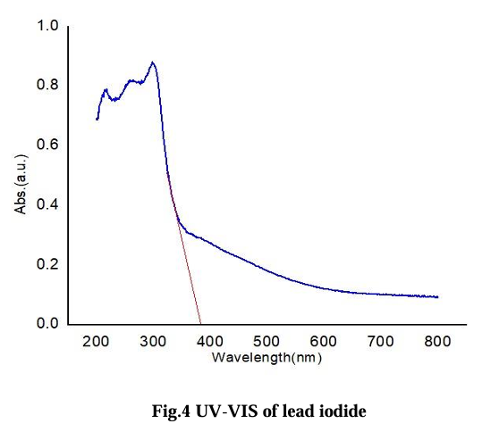

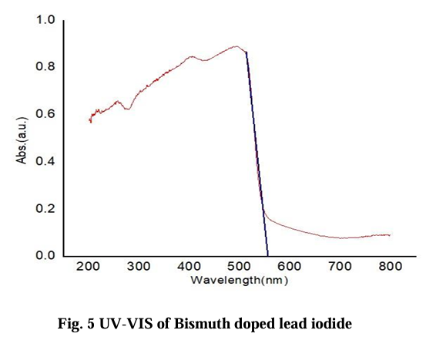

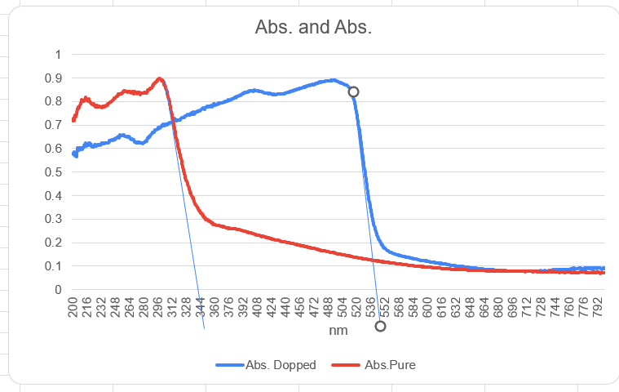

**Figure : Comparison Between UV-VIS of Doped & Undoped Lead Iodide:**

Conclusions

In conclusion, undoped and bismuth doping crystals were successfully prepared using a gel method. The characterization techniques employed showed that the crystals are of good quality. The XRD patterns confirmed that Bi-doping and undoped lead iodide has hexagonal structure for the prepared crystal the impact of bismuth doping on the grain size and optical properties of lead iodide was explored. Peak position is same but changes in intensity due to doping were investigated by XRD, the grain size of bismuth doping was 26.86nm and undoped 27.2 nm. The band gap energy value calculated from UV-VIS spectra. The band gap of bismuth doping and undoped was 2.22eV and 3.22eV. The grain size and band gap energy were found to decrease with doping.

References:

1. Jain Alka and Trigunayt G.C. Acta Crystal A 52 (1996) 590.
2. Agrawal V.K.J. Crystal Growth 53 (1981) 574.
3. Chase A.B.J. Cream. Soc (U.S.A.) 51 (1968).
4. Kuriy S.C.,Roy S.K., S.K., Bose. Mate .Res. Bulletin 31 (3) (1996) 317-327
5. Santoshi Yamazaki and Takanavi Goto J. physical Xociety of Japan vol 5110 (1982)3228.
6. Lee Y and Oh K 2012 J. Instrum. 7 Co410
7. Y. N. Joshi and M. Mazzoni, phys, Lett. A 118, 237(1986)
8. L.caiyan, U. Berzinsh, R. Zerne. And S. Svanberg , Phys. Rev. A 52, 1936 (1995).
9. Solid state Physics C. Kittle
10. Crystal nucleation, solution growth and surface morphology.
11. Solid State Physics-S.O.Pillai, 3rd.Edition, New Age International (P) Ltd, Publisher, (1999)
12. Solid State Physics- Palanyswamy.
13. ZhuangXinxinn, YeLiwang, Zheng Guozong, SuGenbo, HeYoupin, LinXiuqin XuZhihuan (26 November 2010).
14. Solid State Physics – Kakani and Hemrajani, S. Chand Publication
15. Basics of X-Ray Diffraction and Its Applications , K Ramakanth Hebbar (2011)
16. Elements of X-Ray diffraction (third Edition) ,B.D. Cullity, S.R. Stock.
17. Text book for UV-Visible spectroscopy.
18. introduction To Spectroscopy (fifth edition).
19. K. Henisch, J.I. Hanoka and J. Dennis, J. Electrochem. Soc., 112, 627 (1965).
20. ]A. Jain, S. Bhat, S. Pandita, M.L. Kaul and P.N. Kotru, Bull. Mater. Sci., 20, 1089 (1997).

End